- Purpose
  - The purpose of this document is to describe the procedure for assembling an Optima Propane Burnisher deck.
- Scope
  - This SOP applies to all equipment assembly team members. The process applies to the following machines:
E012800EQM0600BE1200 – 21” Optima XR
E012805EQM0600BE1200 – 21” Optima XR w/ Clutch
E012815EQM0600BE1200 – 21” Optima XR w/ Emissions & Clutch
E012830EQM0600BE1200 – 27” Optima XR
E012835EQM0600BE1200 – 27” Optima XR w/ Clutch
E012840EQM0600BE1200 – 27” Optima XR w/ Emissions
- Responsibilities
  - The operations manager/supervisor is responsible for enforcing this SOP.
- Materials
  - The proper materials needed for this process are listed on the machine work order.
  - Hand/Power Tools
- Definitions

- Procedure
  - Start by selecting the correct deck for the machine being built (11281 for 21” machine or 11840 for 27” deck) and wipe it clean with a paper towel and spray bottle. Lay it upside down on the assembly table.
  - Install the swivel caster (86118) into the appropriate hole on the back of the deck. Secure the caster to the deck with a locknut (81088) using a ¾” socket.
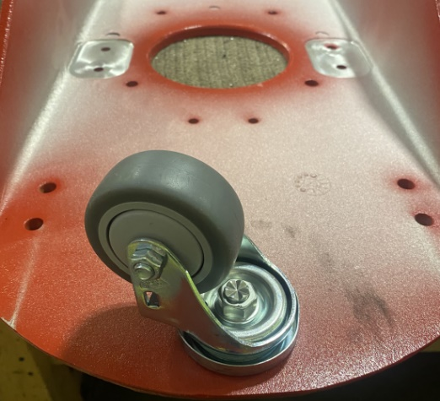

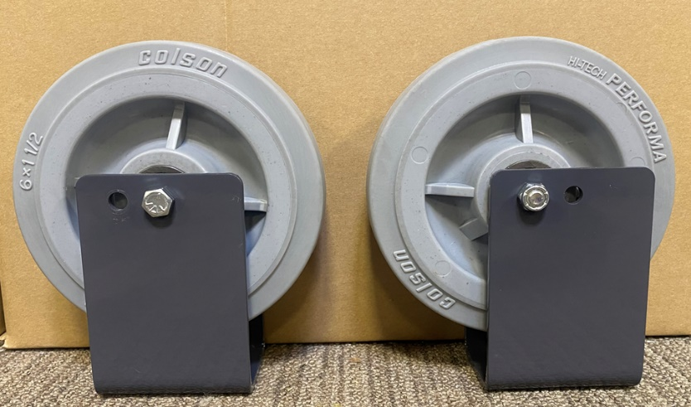
  - Get a set of wheels that were assembled using SOP EQ 075. Ensure the proper brackets are used depending on if a 21” or 27” machine is being built.
21 inch
27 inch

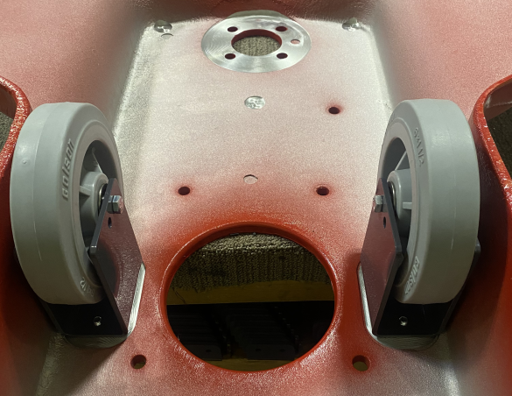
  - Take the completed wheel assemblies and bolt them to the machine deck. Place the wheel brackets so that the head of the bolt faces towards the center of the machine. The nuts should face the outer edge of the deck. Fasten the brackets to the deck using 4 bolts (81089) and 4 lock washers (81067) using a ½” socket.
Bolt heads need to face towards the center

  - Attach the tensioner pulley (29048) to the deck using a bolt (83629), a washer (12447), and a lock washer (81066). Do not tighten the bolt all they way yet. Finger tight is all that is required at this point. The bolt head goes on the top side of the deck.
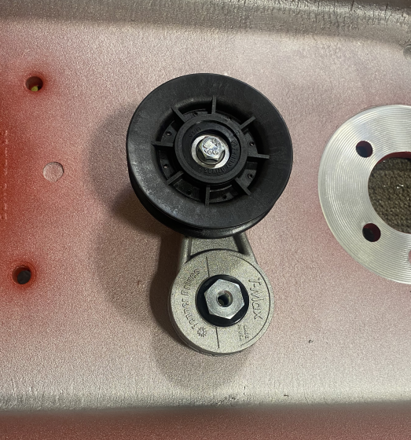

  - Now it is time to shim the center pad driver pulley. Place 1 shim (12609) in the locations shown. Note the orientation of the deck.
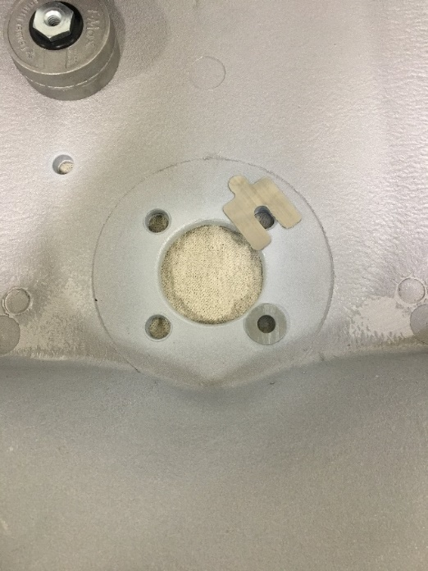
27”
21”
Front of Deck

  - Bolt the center housing assembly (50208) into place (Refer to SOP EQ 147). This is done using 4 bolts (10116), 4 washers (12447), and 4 lock washers (10117) with a 5/8” socket. The housing is bolted from the top side of the deck. The hub part number is stamped into it. Orient that PN on the side shown in the red oval.
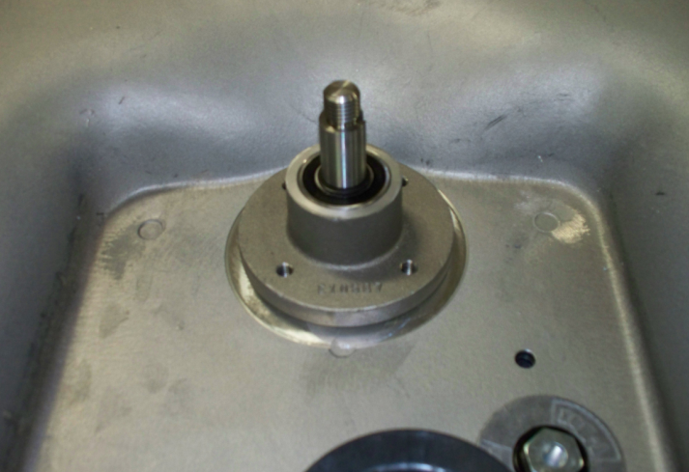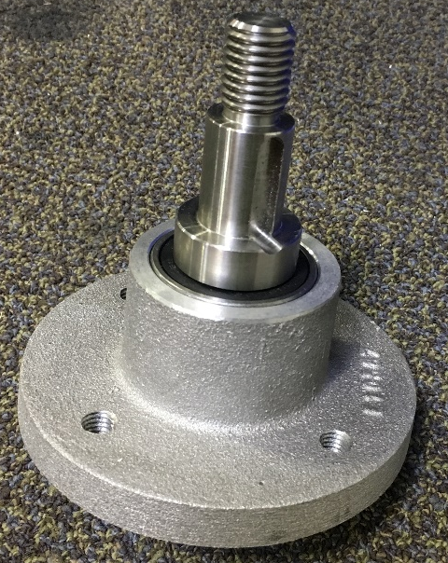

  - Get a front pulley assembly that was built using SOP EQ 073. Slide the assembly onto the main bearing shaft being sure that the keyways line up. Once it is on the shaft, insert the shaft key (12459). You may need to tap it with a hammer. Install the bushing so that the top of it is close to being flush with the shoulder just below the threaded portion of the shaft. Tighten set screw on bushing.

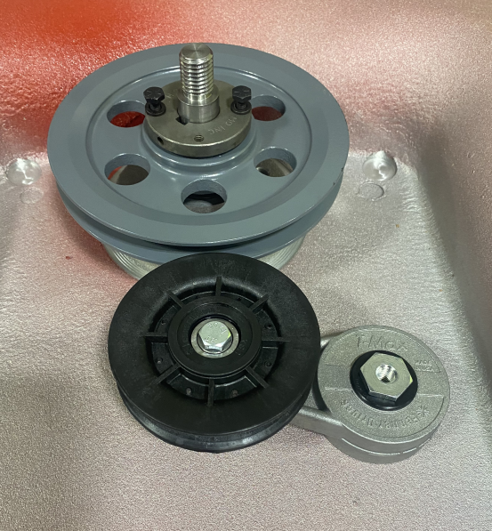
Bushing
Pulley
Screw and washer

  - Tighten the screws on the bushing with a 7/16” Socket. Do not tighten each one individually all the way. Alternate back and forth tightening each one little by little. This will ensure that the assembly does not bind. Once it is tight, spin the pulley and make sure that the pulley stays level and does not wobble. If it does, loosen the screws and re-tighten them. Once tight, verify that the edge of the pulley is flush with the edge of the tensioner pulley. If not, loosen the screws in the bushing, move the assembly up or down the shaft as needed, then re-tighten.
These edges should be flush

  - Flip deck over then pull the deck over the edge of the table. Using a torque wrench to tighten the bearing bolts to 30ft-lbs.
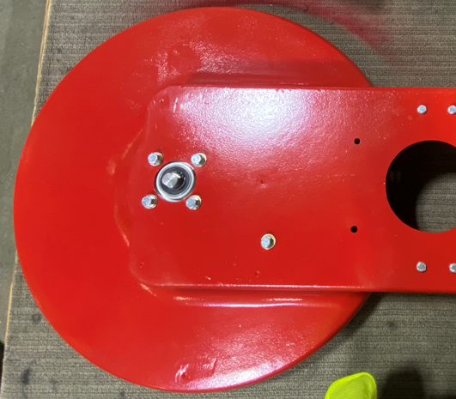
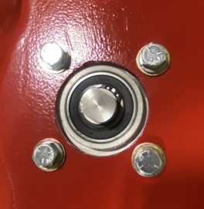
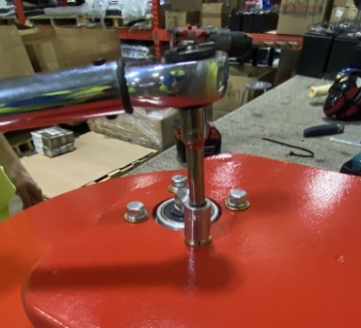
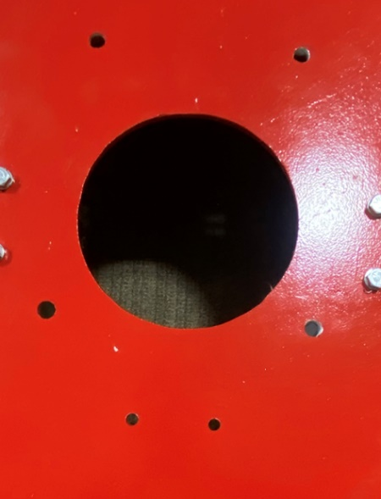
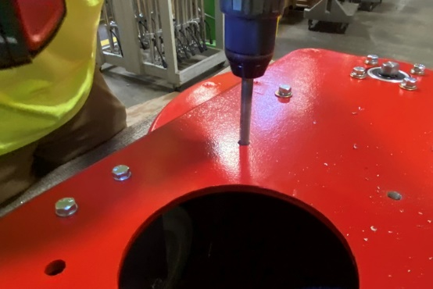
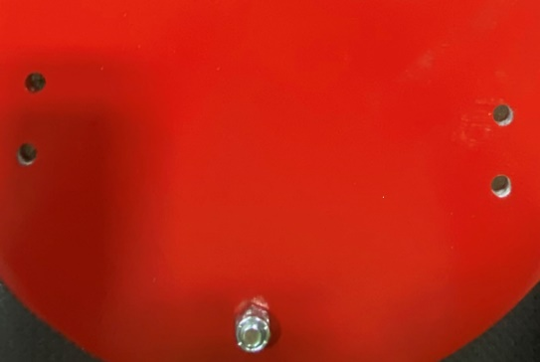
  - Drill out the holes for the motor and handle using drill bit 9/16 to ensure holes are free of debris.
Drill 4 holes for motor placement
Drill 4 holes for handle placement

- References (optional section as needed)

- Training Guide

Functional Training Groups Requiring Training
Equipment Assembly Group

- SOP Change Control

Date of Change | Reason for Change
Rev 01 - 11/22/2013 | This is the first version of the S.O.P. hence there are no revisions to this document.
Rev 02 - 1/15/2018 | Added the Responsibilities section and updated bearing shimming.
Rev 03 - 4/4/2018 | Added updated bearing shimming and bolt torque specs.
Rev 04 - 5/4/2018 | Updated for the Optima XR upgrade
Rev 05 - 3/21/2025 | Removed work center notes and updated machine ID list in Scope 2.01

Approvals

Submitter/Author Approval:__________________________________ Date:______________________

Management Approval:______________________________________ Date:______________________

QAU Approval:_____________________________________________ Date:______________________

